Instructions to use Compassion App:

Within the first two weeks, listen to the seven training files under the training tab. Listen to them in order. They are longer versions of the exercises you will be doing for the main part of the study, so that you have time to get used to the exercise. They range from 5 minutes to 16 minutes, although most are about 10 minutes long. After you finish the seven training exercises, move on to the circumstance tab exercises.

App Icon:

Android App, Training, showing tabs on the top:

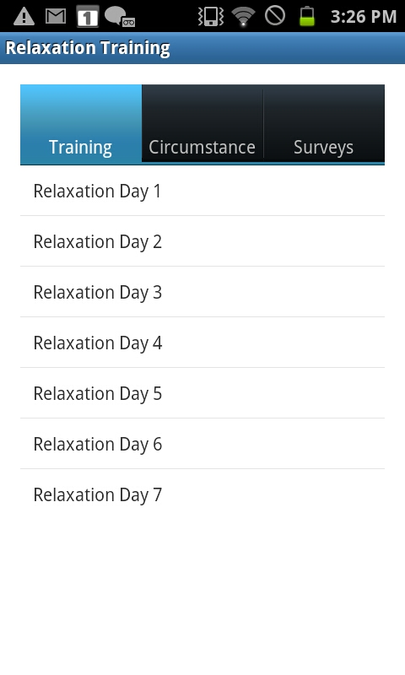

Using the Circumstance app: Use the circumstance app in the real world to prepare for expected stress or help de-stress after a stressful event. There are a lot of different files to chose from with different durations to fit your needs.

1. In this part of the study, you will accrue 25 cents per app usage. Just remember to send the data each week. Select ‘Circumstance’ from the top (Android) or bottom (iPhone) tabs.

iPhone app menu, showing tabs on the bottom:

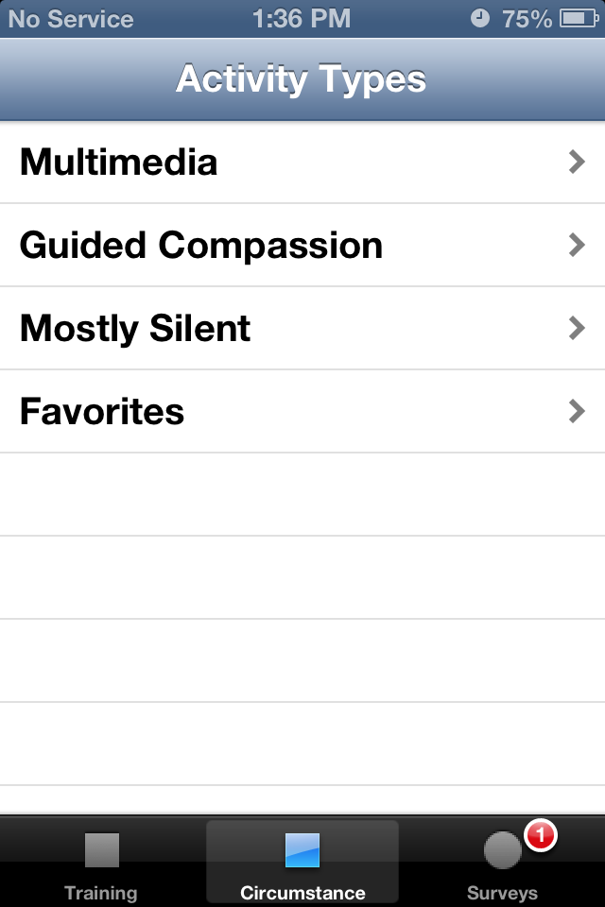

2. Choose the ‘Multimedia” tab and choose whether you want to view to a 1, 3, or 5 minute video file.

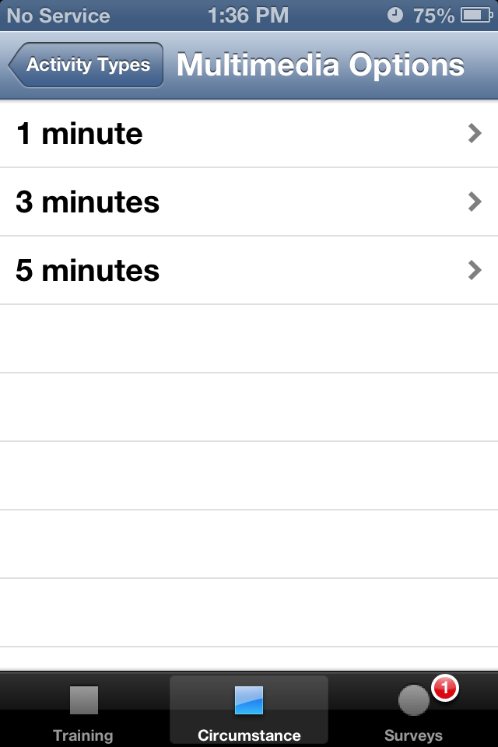

3. All the multimedia files have pictures or videos in lieu of audio files. Here is an example of a 1 min file. Click the link and a Youtube video or webpage will come up. Multimedia only works if you have an internet connection.

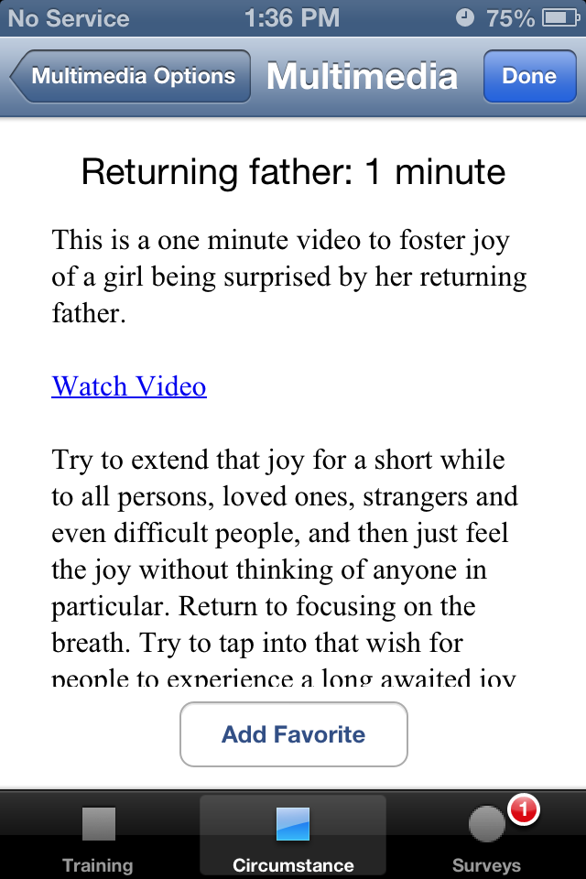

4. All the ‘Guided Compassion’ and ‘Mostly Silent’ files have audio files to listen to.
1) Guided exercises have more frequent hand-on instructions.
2) Mostly Silent has brief instructions at the beginning and sparse instructions afterwards for those who want less interruptions.

We recommend the guided exercises for a while and trying the Mostly Silent once you are familiar with them. When playing there is a play/pause button in the middle of the screen, or bottom of the screen in the Android version (move your finger over bottom to make menu appear). If you really dislike the file, you can hit the back button and re-select the time you would like, and a new file will be randomly chosen (the same is true for multimedia).

iPhone Android
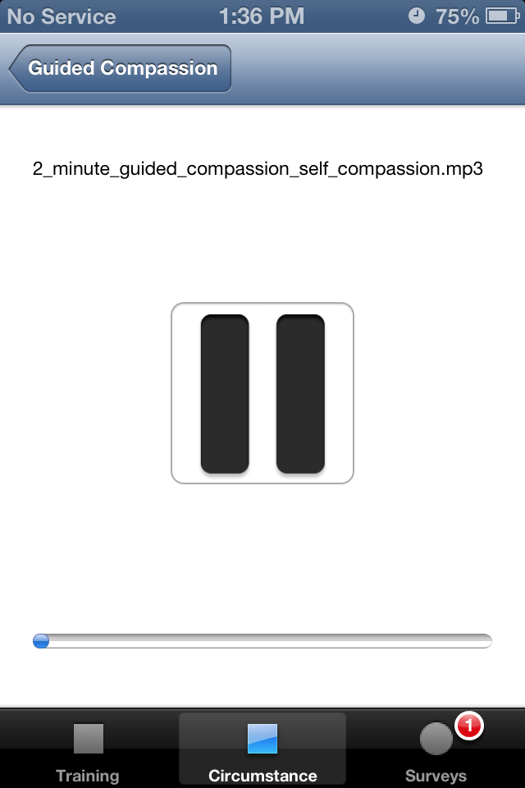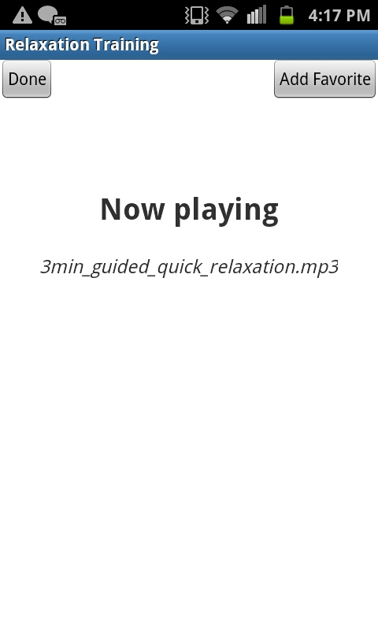

Favorites: If you like a file and want to be able to access it anytime, you can select it as a “favorite” by clicking the button on the upper left “Add Favorites”. Then under the main Favorites menu you will be able to see the file names. You can hit Remove Favorites for an individual file, if you click one by accident or change your mind. There is a separate Favorites menu for audio vs. multimedia files. (For iPhone multimedia, the Favorite button is near the bottom)

5. After completing the ‘multimedia file’ or a ‘guided compassion’ or ‘mostly silent’ audio file, hit “Done” and a survey screen will come up asking you if the stress is anticipated (you are listening to prepare for stress) or unanticipated (something unexpected occurred and you are using the app to help de-stress afterwards.

If this is an unanticipated event, it will automatically give you the survey questions.

On the iPhone, if this is an anticipated event, you can set the time relatively soon to complete the survey.

A screen should then come up under ‘Surveys’ with the time you set for the survey to come up: click on the date to bring up the survey. You will be asked questions on the number of chimes you heard and stress levels.

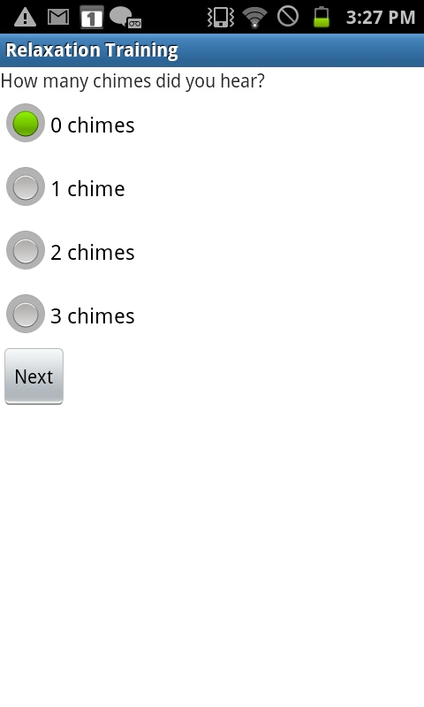

6. After 24 hours, a ‘Next Day Survey’ will appear for you to complete under ‘Surveys’.

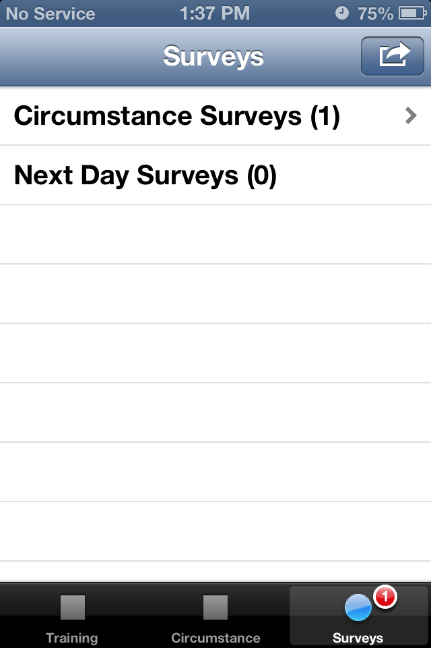

7. Every Sunday night, you can send the survey data.
On the Android use the list button at the bottom of the phone, and it will say “Send Survey Data”

For the iPhone, there is a Send button on the upper right.

Clicking the button, select your email to send, and it will automatically generate an email that will be send to the study’s administrator, Julie Brefczynski-Lewis. The survey data will be encrypted and confidentially e-mailed.

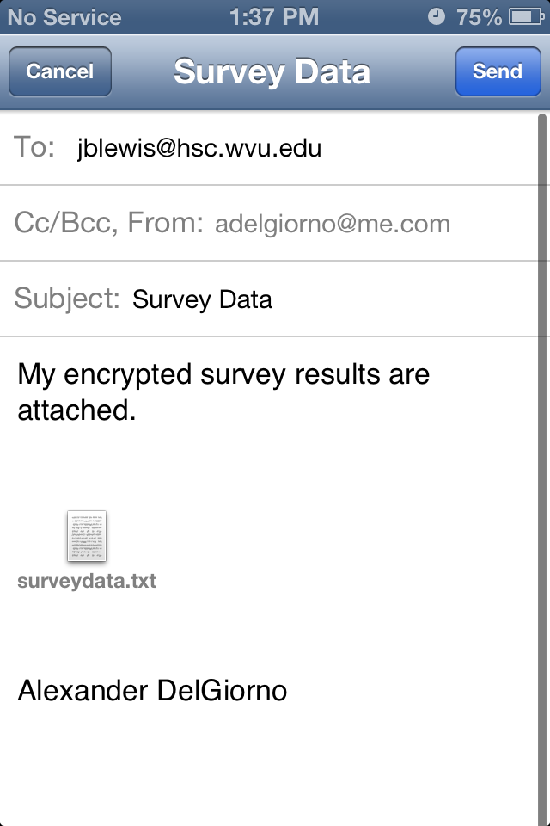

Feel free to contact us through email at appstudywvu@gmail.com or by phone at (304) 293-4820 if you have any questions.

